STUDENT CASE STUDY EXECUTION REPORT
Department | FED
Subject | DSA-2
Academic Year | I-III Semester (2025-26)
Faculty Name | Balaiah Gudipudi
Student Name | N . Teja sri
Roll Number | 2520030139
Branch | CSE
Course Outcome | 4
Case Study Topic: Aadhaar UID de-duplication — sort 1.4 billion 12-digit numbers.

Work Done Summary
In this case study, we analyzed UIDAI's Aadhaar de-duplication problem and explored the use of LSD (Least Significant Digit) Radix Sort for sorting large volumes of UID numbers.
We implemented Radix Sort on a sample dataset of 3-digit UID numbers and observed how the numbers are sorted digit-by-digit from the least significant digit to the most significant digit.
We also compared Radix Sort with comparison-based sorting and demonstrated why Radix Sort is more efficient for fixed-length numeric identifiers such as Aadhaar numbers.

Implementation Details
- Stored UID numbers in an integer array.
- Identified the maximum number to determine the number of digit passes.
- Applied Counting Sort on each digit position (ones, tens, hundreds).
- Maintained stability during every sorting pass.
- Displayed the array after each digit pass.
- Obtained the final sorted UID list for duplicate detection.

Result: Screenshots / Output
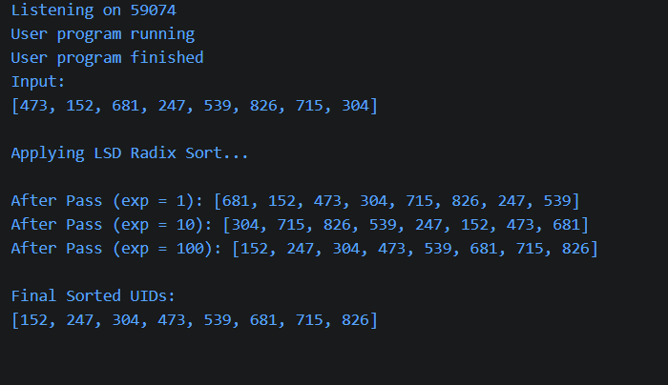
Time Complexity:
- Radix Sort: O(d × n)
- Counting Sort (per pass): O(n + k)
Radix Sort successfully sorted the UID numbers by processing one digit at a time while maintaining stability. For fixed-length identifiers such as Aadhaar numbers, Radix Sort is more efficient than comparison-based sorting and is well suited for large-scale duplicate detection systems.
GitHub Link: NTejasri-2520030139/CO-4_Case-Study
Student Signature | Faculty Signature
________________ | ________________

